**Orbilogin.com**

Looking for a fast, reliable, and most secure wifi network? If yes, then cover your entire home network with the [**Netgear Orbi WiFi system**](http://orbiwifisystem.com/).

The Orbi WiFi system comes with one router and one or more satellites. The Orbi WiFi network distributes wifi signals even to the farthest corners of your place. This guide is made to help you with the Orbilogin.com setup.

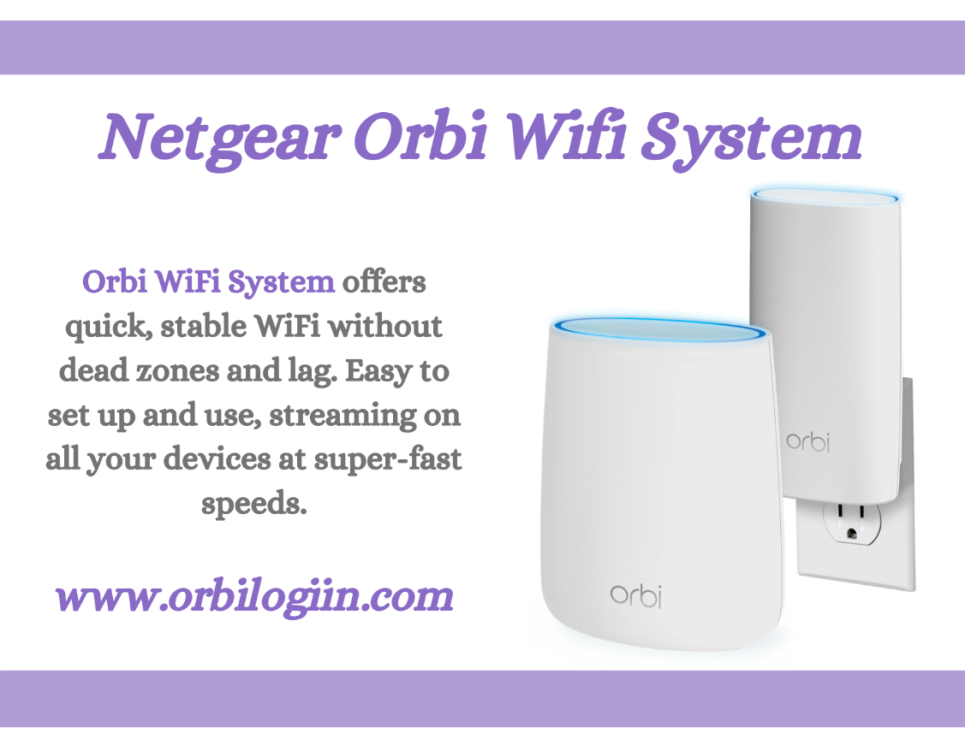

Doing the above would require you to do some basic setup exercise with your netgear Orbi router setup first. After making the initial setup connection, you would be able to climb up the ladder of installation.

For those, who don’t know the steps to set up orbi wifi system, you would need to follow this guide on the [**Orbilogin.com**](https://www.orbilogiin.com/) setup.

Netgear orbi login is the first step for the configuration and installation Orbi WiFi system. You would need the default web address orbilogin.net or orbilogin.com or Orbi login address to get into Orbi login page. If your orbilogin.net not working or your orbi can’t get ip addressthen try to fix the error by resetting your orbi router.

Harnessing issues during the Netgear orbi setup is a common occurrence. It is important to fix these issues permanently. If you want to fix the issue then you would need to reset Orbi router satellite. To know how to reset orbi routeror [**how to reset orbi satellite**](https://orbioutdoorsatellite.com/), refer to the following steps.

**A Detailed Guide on Netgear Orbi Setup**

As mentioned above, it is important to make the hardware connection before logging into orbi router. Here are a few [**Netgear Orbi setup instructions**](https://orbioutdoorsatellite.com/netgear-orbi-installation/). Follow them carefully.

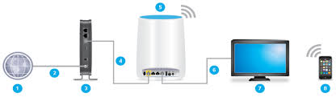

**Step 1-** To begin with, you need to unplug and shut down your modem. Use an ethernet cable to connect the orbi device to the broadband modem. Reconnect the modem to the power source.

**Step 2-** Connect the power adapter to the back of the Orbi router and plug it into the power outlet. Press the power button on the orbi router. Check for the power LED. When the power LED turns solid white, you can begin with [**Netgear orbi login**](https://netgerorbilogin.com/).

**Step 3-** Next, you need to establish a connection of your laptop with Orbi network. Load on a web browser on the device that is connected to orbi router.

**Step 4-** You would need to type orbi login address to open up the login page. In case, your orbi can’t get ip address, you can make use of web address orbilogin.net or orbilogin.com. You will see the orbi login window asking for username and password.

**Step 5-** Enter the orbi router login credentials and click on the ‘login’ option. If you can’t get in using the login credentials, you would need to reset your device to its default settings. To know how to reset orbi router, jump to the next section.

**Step 6-** Once you’re into orbi setup page, you can change the default login credentials as per your convenience. Change the wireless security settings of the orbi device as per your ease. Save the settings, in the end, to apply the changes for **orbilogin.net** setup.

**Troubleshoot- Sync Orbi Router to Orbi Satellite**

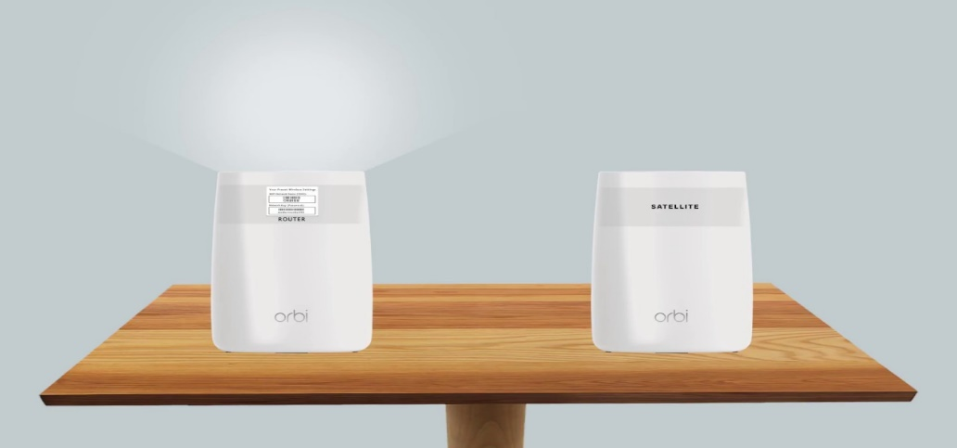

Having issues while syncing Orbi router to satellite? We suggest you to place the orbi satellite in the same room as your router during the sync process.

**Step 1-** Place the Orbi satellite near to your router. Connect it to the nearby power source. Check the power LED on the backside of the device. Press the Power button.

**Step 2-** Now, press the sync button on the orbi satellite and wait for a few minutes. Press the sync button located on the backside of the orbi router. If you see a blue light, it means the connection process is completed.

**Step 3-** In the case of magenta LED, you will need to bring orbi satellite closer to the router. The connection is failed.

**Troubleshooting- Orbi Router and Satellite Reset process**

If orbi can’t get ip address then you would need to reset your orbi device. With a few steps, you can troubleshoot [**orbi login**](https://www.orbilogiin.com/orbi-login/) failed error. Check out how to reset orbi router.

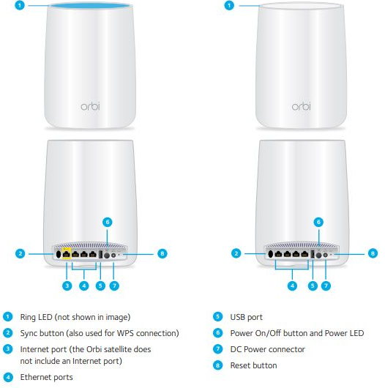

* Connect your orbi router to the power source and make sure it is powered ON.
* Use a paper clip or blunt object to press and hold the reset button. Leave the button when the Orbi power LED starts to blink.

Follow the steps to know how to reset orbi satellite-

* Make sure your orbi satellite is powered ON.
* Press and hold down the orbi satellite’s reset button with the help of a pointed object for a few seconds. When the power LED starts to blink amber, leave the button.

After completing the reset process, you can get onto orbi login page with the web address **orbilogin.com** or orbi login address.

If you need more info on [**orbilogin.net setup**](https://www.orbilogincom.net/), you can get in touch with our team of experts. Our technicians are available round the clock to guide you with Orbi installation and troubleshooting.